TOUR TRAVEL

INTRODUCTION:-

This introduction is usually short (5 minutes) and is normally structured like this: Say hello, welcome them, thank them for booking with you, introduce the tour and get the travelers' interest.

BRAINSTROAM

1. Word association. Take a sheet of paper and start jotting down any words that come to mind when thinking of your project. ...
2. Create a mood board. The most visual of brainstorming types, mood boards are great for communicating ideas that can't be easily expressed with words. ...
3. Cubing.

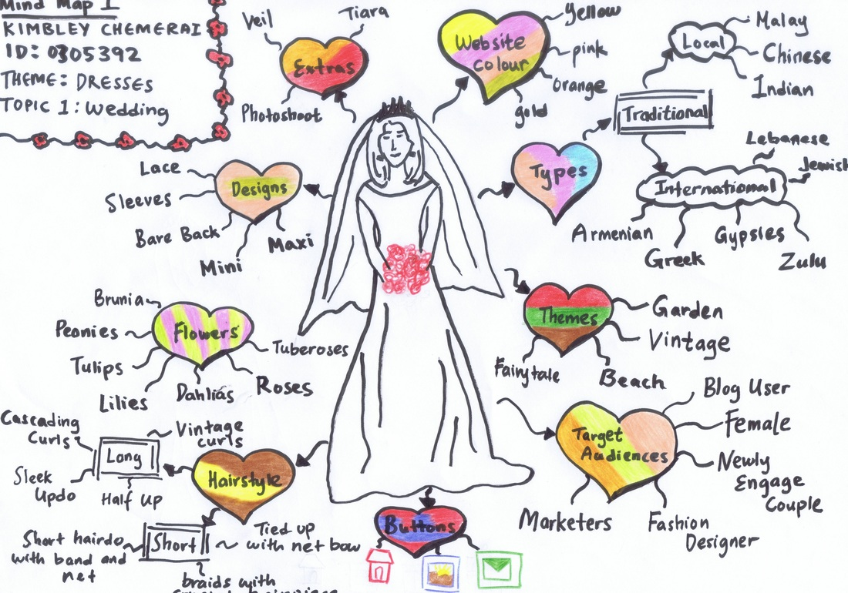

EMPATHY MAP:-

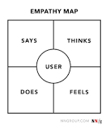

Empathy maps provide a glance into who a user is as a whole and are not chronological or sequential. The Says quadrant contains what the user says out loud in an interview or some other usability study. Ideally, it contains verbatim and direct quotes from research

CONCLUSION:-

In conclusion the project focussed on Travel Tour has been comprehensive exploration of the business, its operations , and the proposed solution of implementation on online service platform. Through the project,several key findings and insights have emerged .It is very useful to us.